Project Proposal 

#### *Chromilo Amin | Thursday, December 10, 2020 | Bertelsmann Technology Scholarship program*



# Data Labeling Approach

|  |  |
| --- | --- |
| **Project Overview and Goal**What is the industry problem you are trying to solve? Why use ML in solving this task? | The goal is to build a product that will help doctors quickly identify cases of pneumonia in children. We hope to train ML to correctly identify with high confidence level the presence of pneumonia from a set of images. The images will have a mix of healthy and abnormal lungs. |
| **Choice of Data Labels**What labels did you decide to add to your data? And why did you decide on these labels vs any other option? | Cloudiness_present – this is a yes-no selection  Diapragm_present – this is a yes-no selection  Heart_present - this is a yes-no selection  Cloudy_types this is a checkbox selection asking annotator to indicate whether the cloudiness is a big patch or various small patches, and on which side of the lung  Confidence_level – this is a number from 1-3 with 1 being not confidence, 2 as somewhat confident, and 3 the most confident in the answers.  Confidence_detail – this is a text field that comes up if the annotator picked 2 for confidence level above. |

# Test Questions & Quality Assurance

|  |  |
| --- | --- |
| **Number of Test Questions**Considering the size of this dataset, how many test questions did you develop to prepare for launching a data annotation job? | I picked 3 images with abnormal readings and 2 with healthy readings for a total of 5 samples. |
| **Improving a Test Question**Given the following test question which almost 100% of annotators missed, statistics, what steps might you take to improve or redesign this question? | I’ll make sure this test ID uses the validates="required" attribute to ensure the annotators don’t miss it. |
| **Contributor Satisfaction** Say you’ve run a test launch and gotten back results from your annotators; the instructions and test questions are rated below 3.5, what areas of your Instruction document would you try to improve (Examples, Test Questions, etc.) | <your text here> |

# Limitations & Improvements

|  |  |
| --- | --- |
| **Data Source**Consider the size and source of your data; what biases are built into the data and how might the data be improved? | The dataset contains 117 rows of images. To ensure non-biased results, the number of questions asked should evenly contain healthy, unhealthy, and inconclusive data sets. I used 1 test question for every 19 data points so that is about 6 questions needed. |
| **Designing for Longevity**How might you improve your data labeling job, test questions, or product in the long-term? | I would continually survey the human annotators to query their satisfaction with the test questions, ease of completing them, areas of improvement, and providing some incentive for helping improve the data labeling job like offering gift cards. |

# Appendix A – CML code

<div class="row-fluid">

<div class="span6">

<img src="{{hosted_image}}"/>

</div>

<div class="span6">

<cml:radios name="cloudiness_present" label="Do you see any areas of abnormal cloudiness/opacity in the lung?" validates="required">

<cml:radio value="yes" label="Yes"/>

<cml:radio value="no" label="No"/>

</cml:radios>

<cml:radios name="diapragm_present" label="Do you see a diaphragm shadow?" validates="required">

<cml:radio value="yes" label="Yes"/>

<cml:radio value="no" label="No"/>

</cml:radios>

<cml:radios name="heart_present" label="Do you see the heart?" validates="required">

<cml:radio value="yes" label="Yes"/>

<cml:radio value="no" label="No"/>

</cml:radios>

<cml:checkboxes name="cloudy_types" label="What area of the lung is opaque?" validates="required" only-if="cloudiness_present:[yes]" exact="true">

<cml:checkbox value="lhs" label="Big patch on left lung"/>

<cml:checkbox value="rhs" label="Big patch on right lung"/>

<cml:checkbox value="several" label="Several small cloudy areas on both sides"/>

</cml:checkboxes>

<cml:select name="confidence_level" label="How confident are you?" validates="required" only-if="cloudiness_present:[yes]" exact="true">

<cml:option label="1-not confident" value="1"/>

<cml:option label="2-somewhat confident" value="2"/>

<cml:option label="3-very confident" value="3"/>

</cml:select>

<cml:textarea name="confidence_detail" label="Confidence Level detail:" validates="required" only-if="confidence_level:[2]" exact="true"/>

</div>

</div>

# Appendix B – Preview of Job

# **Overview**

Help us determine if the images show a healthy lung or if the patient has pneumonia.

# **Steps**

1. Examine the image and properly identify these annotated areas in the image.

* lungs
* spine
* heart
* ribcage
* diaphragm (below the lungs)

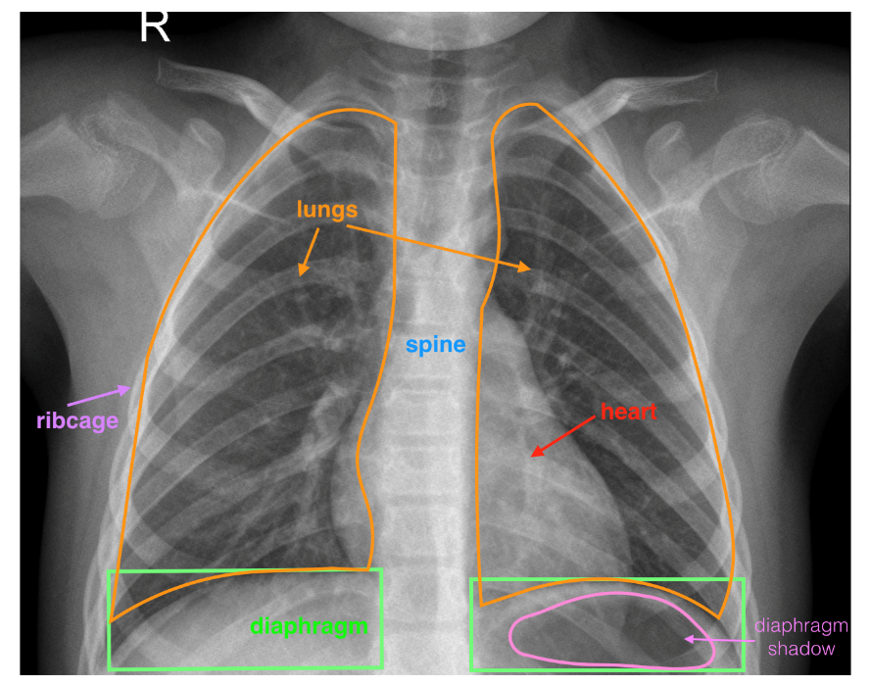

2. Check the appropriate box if the image shows clear lungs without any areas of abnormal cloudiness/opacity.

3. Check the appropriate box if the image shows the diaphragm shadow.

4. Check the appropriate box if the image shows the heart.

5. Indicate your confidence level in making your above choices from 1-3.

6. If you are somewhat confident (you picked confidence level 2 above), then type your reasons.

# **Rules Tips**

**Rules:**

* Categorize cloudiness as either whole patches or small regions;
* If you are not confident in your answers, type the reason.

**Tips**:

* The R in every image indicates the right hand side. Please be careful when answering the checkbox indicating which side of the lung is cloudy.

# Examples

|  |  |  |  |  |
| --- | --- | --- | --- | --- |
| Normal and healthy | |  | | |
| Abnormal with possible pneumonia |  | | |
| Abnormal with possible pneumonia | | |  |